**SPRINT 2 REQUIREMENTS ARTIFACT**

1. Ability to see followers of other users (Requirement-ID 5) - ***User Interface Model***
2. Send notification to other users on making a post (Requirement-ID 9) - ***User Interface*** *Model*
3. Ability to like/dislike posts (Requirement-ID 10) - ***User Interface Model***
4. Add ability to change usernames (Requirement-ID 19) - ***User Story***
5. Make sure the website is responses and runs fast (Requirement-ID 21) - ***User Story***
6. Make the webapp containerized (Docker or Kubernetes) for easier deployements (Requirement-ID 23) - ***User Story***
7. Send notifications on likes on a post (Requirement-ID 25) - ***User Interface Model***
8. Add a dashboard for each player with number of wins, losses and ties (Requirement-ID 27) - ***User Interface Model***
9. In-game chat feature during tic-tac-toe matches (Requirement-ID 30) - ***User Interface Model***

1. Ability to see followers of other users (Requirement-ID 5) - ***User Interface Model****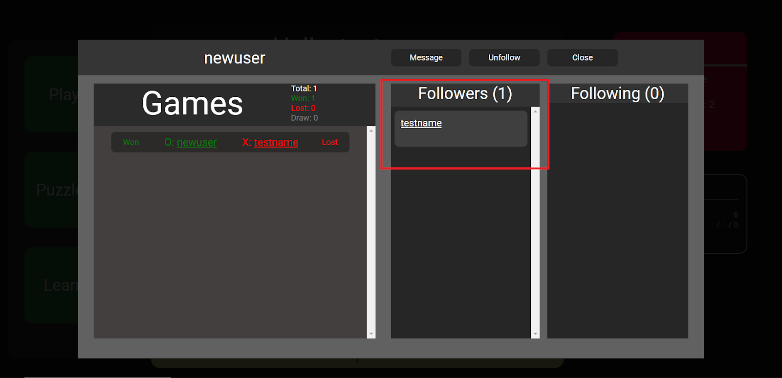*

2. Send notification to other users on making a post (Requirement-ID 9) - ***User Interface Model***

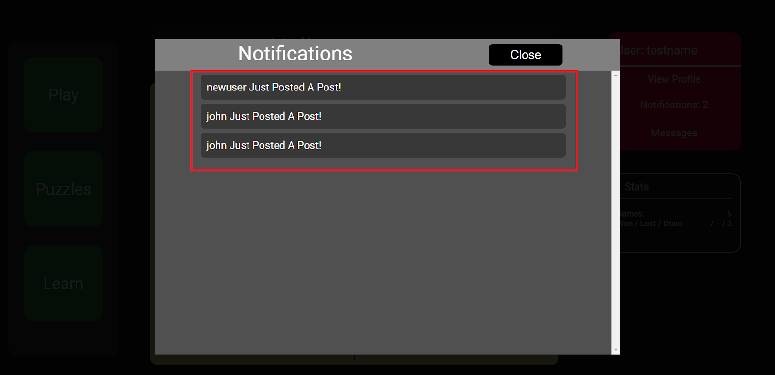

3. Ability to like/dislike posts (Requirement-ID 10) - ***User Interface Model***

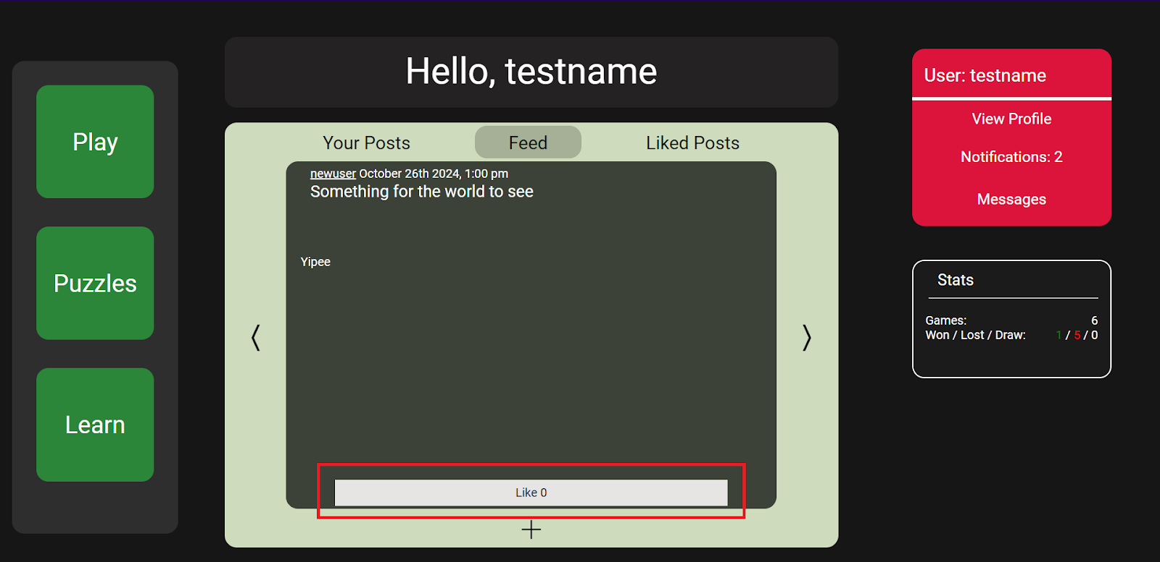

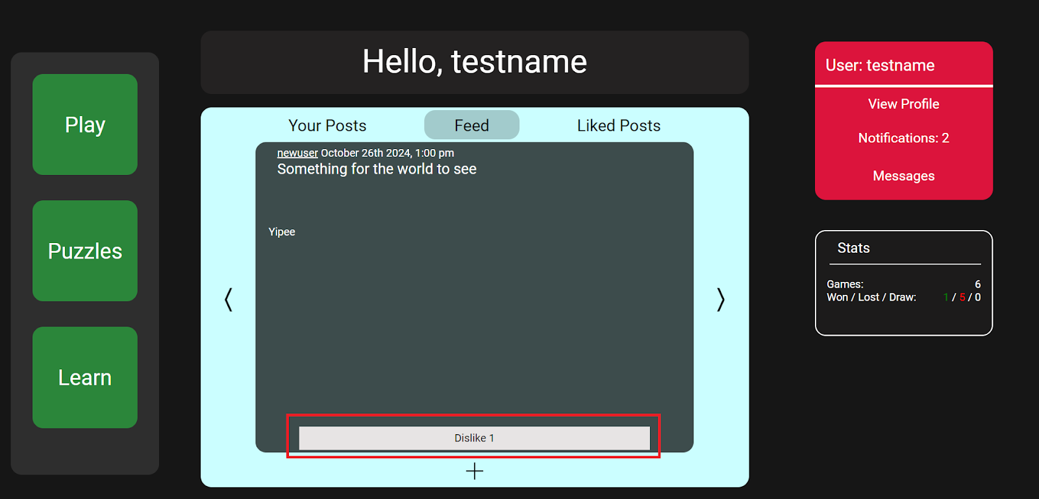

4. Add ability to change usernames (Requirement-ID 19) - ***User Story***

1. Users want to change inappropriate usernames
2. Users prefer to have a new username

5. Make sure the website is responses and runs fast (Requirement-ID 21) - ***User Story***

1. Users experience delays when playing against user
2. Users experience delays when playing against a computer bot
3. Users want to see real-time number of likes on a post

6. Make the webapp containerized (Docker or Kubernetes) for easier deployements (Requirement-ID 23) - ***User Story***

1. Users want to deploy the webapp within their organization and need easy deployment methods
2. Users want to develop the webapp without installing required packages permanently on their machines
3. Users want to scale the webapp and multiple containers with a swarm via Kubernetes makes the process easier

7. Send notifications on likes on a post (Requirement-ID 25) - ***User Interface Model***

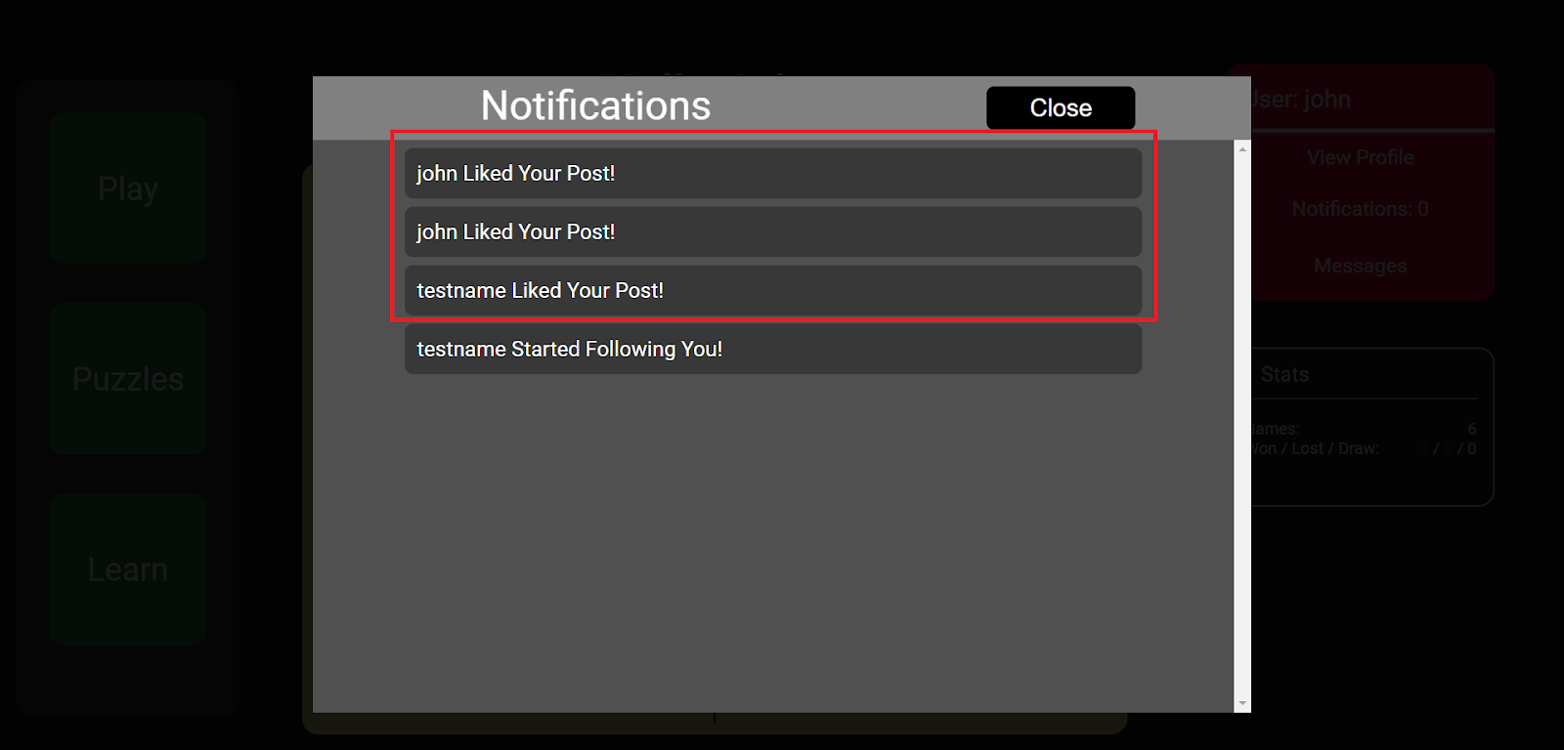

8. Add a dashboard for each player with number of wins, losses and ties (Requirement-ID 27) - ***User Interface Model***

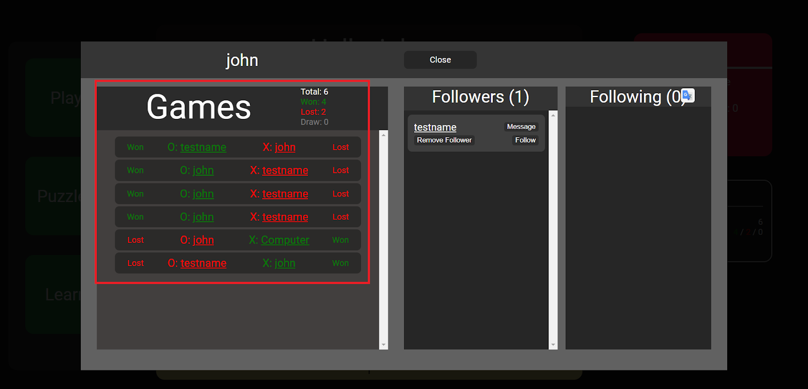

9. In-game chat feature during tic-tac-toe matches (Requirement-ID 30) - ***User Interface Model***

